Test Case: tc003_SPX_Dev5_Crear_Requisicion_Spot_Tipo_Cobro_CC_Urgent
Step 1 - Enter username and password and click to button Enter : Credentials Entered
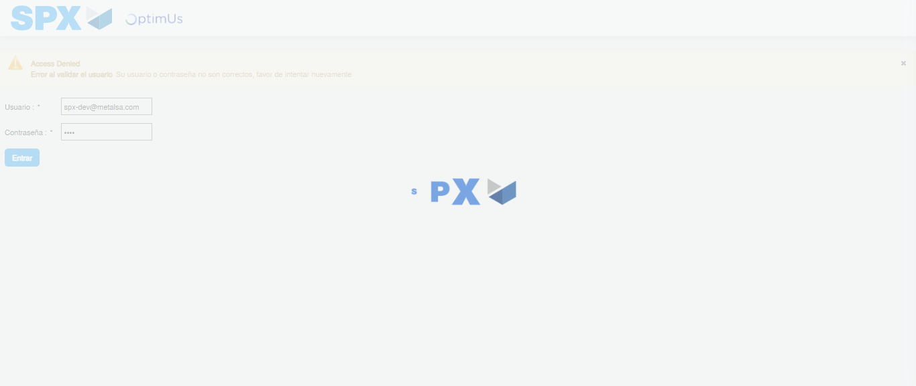Image file-name: QC_Testing-tc003_SPX_Dev5_Crear_Requisicion_Spot_Tipo_Cobro_CC_Urgent-1783356483198

Step 2 - Select to UEN and Access to Spot Buy Requisitions : UEN Correctly selected and Correct access
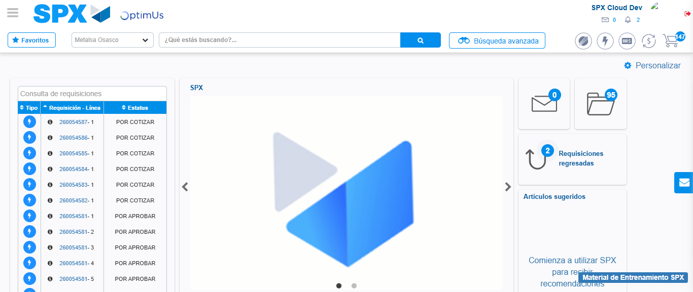Image file-name: QC_Testing-tc003_SPX_Dev5_Crear_Requisicion_Spot_Tipo_Cobro_CC_Urgent-1783356507993

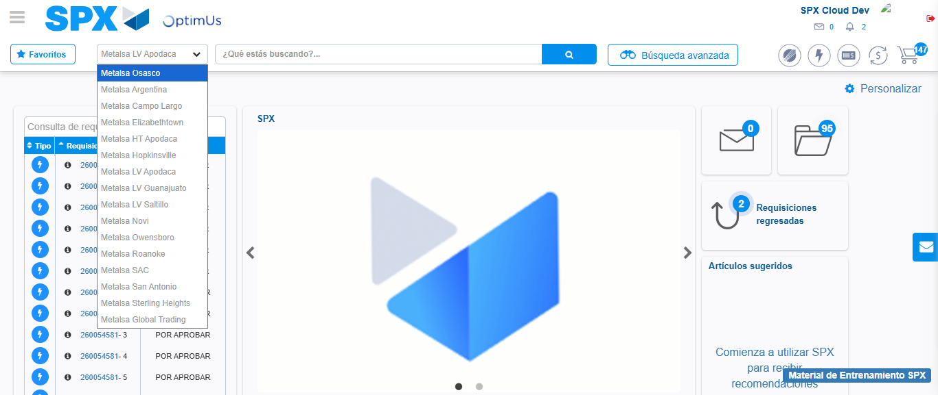Image file-name: QC_Testing-tc003_SPX_Dev5_Crear_Requisicion_Spot_Tipo_Cobro_CC_Urgent-1783356510757

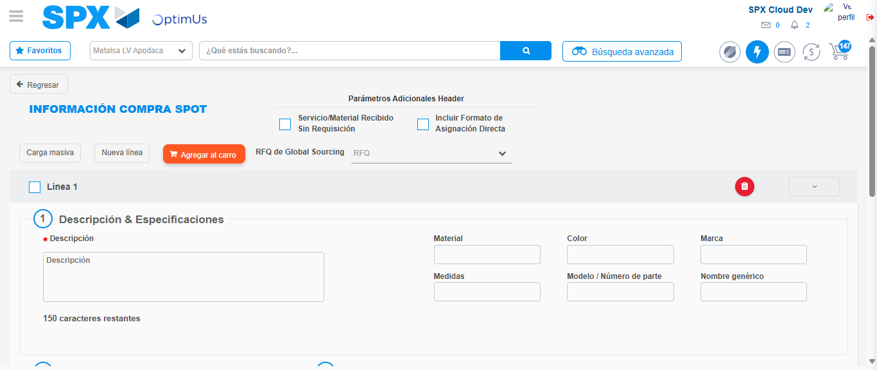Image file-name: QC_Testing-tc003_SPX_Dev5_Crear_Requisicion_Spot_Tipo_Cobro_CC_Urgent-1783356536024

Step 3 - Data Capture Spot Buy Requisition: Data captured correctly
Image file-name: QC_Testing-tc003_SPX_Dev5_Crear_Requisicion_Spot_Tipo_Cobro_CC_Urgent-1783356536280

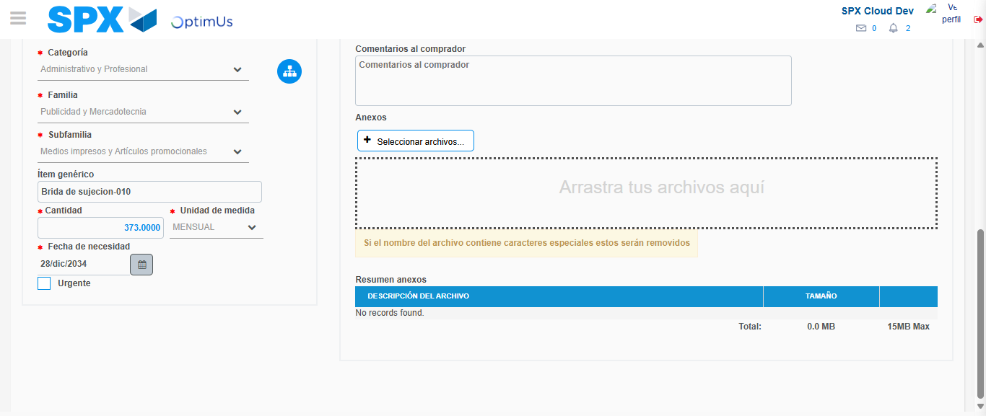Image file-name: QC_Testing-tc003_SPX_Dev5_Crear_Requisicion_Spot_Tipo_Cobro_CC_Urgent-1783356546202

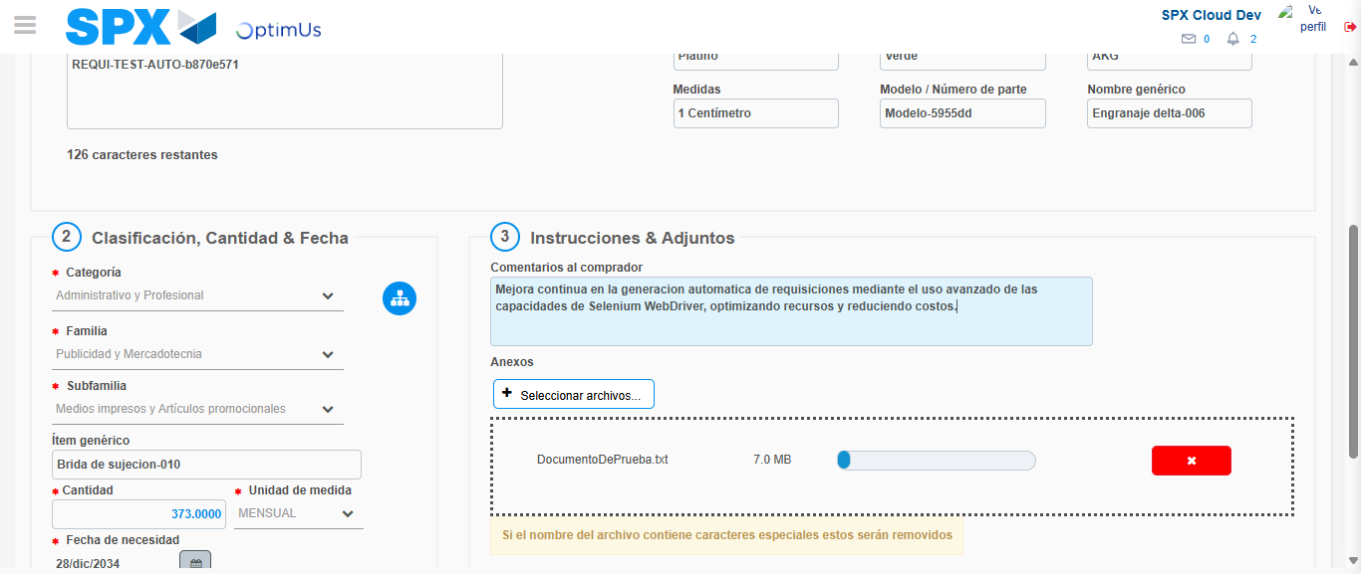Image file-name: QC_Testing-tc003_SPX_Dev5_Crear_Requisicion_Spot_Tipo_Cobro_CC_Urgent-1783356546942

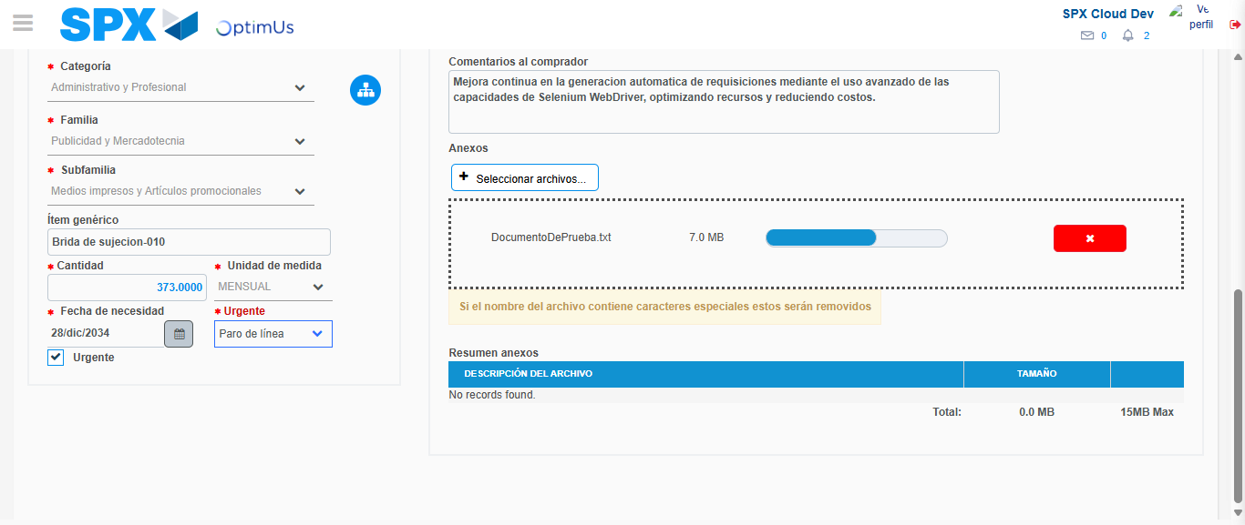Image file-name: QC_Testing-tc003_SPX_Dev5_Crear_Requisicion_Spot_Tipo_Cobro_CC_Urgent-1783356550604

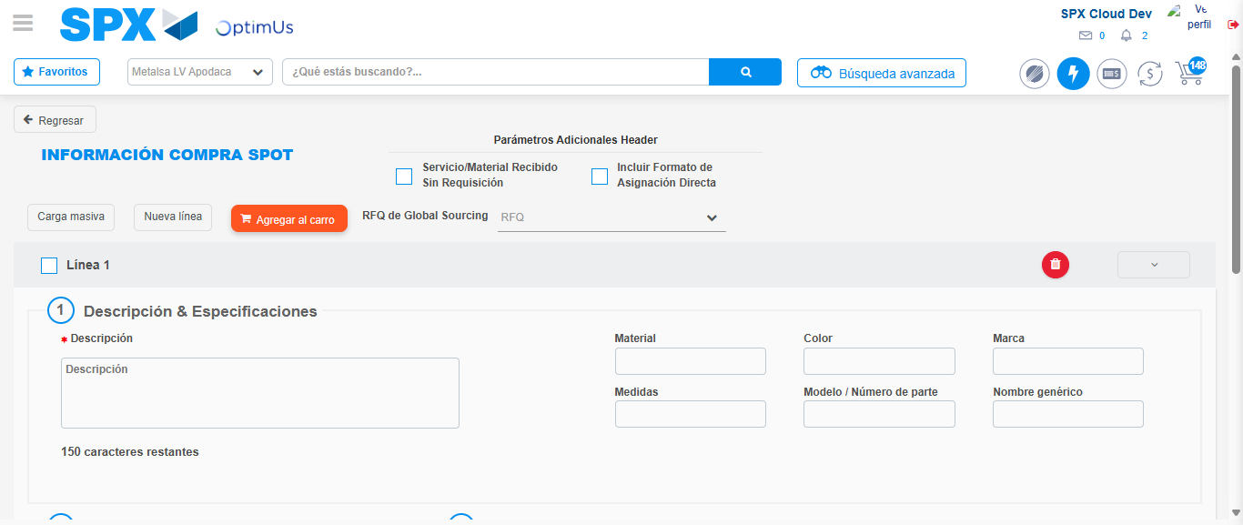Image file-name: QC_Testing-tc003_SPX_Dev5_Crear_Requisicion_Spot_Tipo_Cobro_CC_Urgent-1783356553591

Step 7 - Return to Main Page SPX : Return to Main Page SPX
Image file-name: QC_Testing-tc003_SPX_Dev5_Crear_Requisicion_Spot_Tipo_Cobro_CC_Urgent-1783356507993

Image file-name: QC_Testing-tc003_SPX_Dev5_Crear_Requisicion_Spot_Tipo_Cobro_CC_Urgent-1783356510757

Image file-name: QC_Testing-tc003_SPX_Dev5_Crear_Requisicion_Spot_Tipo_Cobro_CC_Urgent-1783356536024

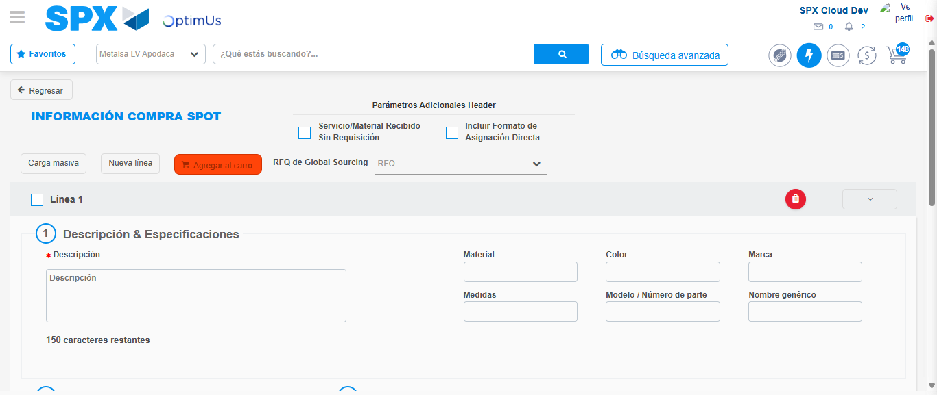Image file-name: QC_Testing-tc003_SPX_Dev5_Crear_Requisicion_Spot_Tipo_Cobro_CC_Urgent-1783356555824

Image file-name: QC_Testing-tc003_SPX_Dev5_Crear_Requisicion_Spot_Tipo_Cobro_CC_Urgent-1783356556014

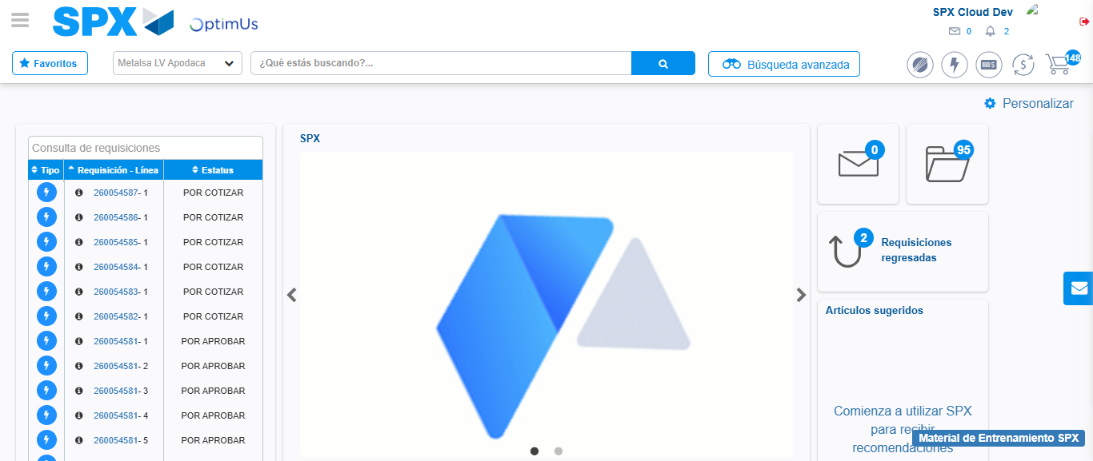Image file-name: QC_Testing-tc003_SPX_Dev5_Crear_Requisicion_Spot_Tipo_Cobro_CC_Urgent-1783356577115

Step 8 - Log Out : Log Out SPX
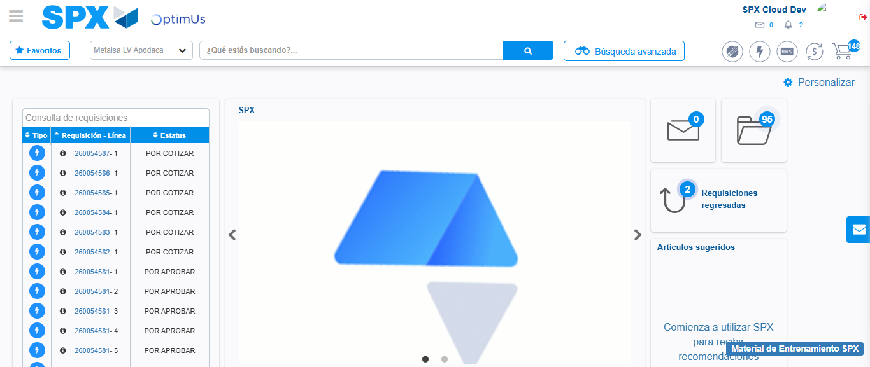Image file-name: QC_Testing-tc003_SPX_Dev5_Crear_Requisicion_Spot_Tipo_Cobro_CC_Urgent-1783356577434

